CIFAKE: Image Classification and Explainable Identification of AI-Generated Synthetic Images

Abstract: Recent advances in synthetic data generation have made it increasingly difficult for humans to differentiate between real-life photographs and AI-generated images. To address the critical need for data reliability and authentication, a method is proposed to enhance the identification of AI-generated images using computer vision techniques. The synthetic dataset, modeled after the CIFAR-10 dataset, was generated through latent diffusion to create a set of images for comparison with real photographs. The approach utilizes computer vision algorithms, with a focus on CNN2D for image classification. A modified version of CNN2D is employed to improve performance, achieving an impressive accuracy of 95.77%. This method enables more reliable detection of synthetic images, providing an effective solution to the growing concern of AI-generated media. The results demonstrate the high potential of computer vision in distinguishing real and synthetic images, offering a powerful tool for ensuring data integrity and trust in digital content.
“Index Terms - AI-generated images, generative AI, image classification, latent diffusion”.
1. INTRODUCTION
The field of synthetic image generation by Artificial Intelligence (AI) has made remarkable advancements in recent years, transforming how images are produced and consumed. Early AI-generated images often contained noticeable visual defects that made them easy to differentiate from real photographs. However, with the advent of more sophisticated techniques, these generative models have evolved to create highly realistic images indistinguishable from those captured by humans. One of the most notable breakthroughs in this area is the development of Latent Diffusion Models (LDMs), which are capable of generating high-quality, photorealistic images in a matter of seconds. This technology has revolutionized the creative industry, with AI-generated art now competing with human-created works and even winning art competitions [1].
Despite these advancements in image generation, the rise of AI-generated content has raised significant concerns about authenticity, privacy, and trust. LDMs and other generative models have made it possible to create realistic images with no basis in reality, posing a challenge for traditional image verification systems [2]. This has created a new set of problems for fields like digital media, law enforcement, and journalism, where the authenticity of images is crucial for the integrity of information. As the technology continues to advance, distinguishing between real and AI-generated images has become increasingly difficult for the human eye, threatening the reliability of image-based evidence and media content [3][4].
The growing realism of AI-generated images has also led to concerns about the ethical and societal implications of synthetic media. With consumer-level technology now capable of generating such high-fidelity images, there is potential for misuse, including the violation of privacy, the spread of misinformation, and even the perpetration of fraud. These concerns are particularly pressing in the context of deepfakes, where AI is used to manipulate images and videos of real people for malicious purposes [5]. The ability to create highly convincing synthetic images opens up new avenues for deception, challenging existing frameworks for verifying digital content [6].
These developments raise fundamental questions about the nature of trust and authenticity in the digital age. The ease with which AI can now generate convincing visual content necessitates a rethinking of how we assess the credibility of images and how technology impacts our perception of reality. As AI-generated imagery continues to advance, it is essential to develop systems that can accurately detect synthetic images to protect against fraud, misinformation, and privacy violations [7]. Addressing these challenges will be key to ensuring the integrity of digital content and maintaining trust in the authenticity of image data.
2. RELATED WORK
Recent advancements in AI-generated image detection and synthetic image generation have gained significant attention in the academic and research communities due to the increasing realism of synthetic media. One of the leading areas of research focuses on the identification of synthetic images created by various generative models, including text-to-image generation and diffusion models.
Sha et al. (2022) introduced DE-FAKE, a system designed for the detection and attribution of fake images generated by text-to-image models. Their work addresses the challenge of detecting images produced by generative models, particularly focusing on the discrepancies between real and AI-generated images. By analyzing the properties of generated images and incorporating attribution techniques, they offer an efficient approach for identifying synthetic content [8].
Similarly, Corvi et al. (2022) explored the detection of synthetic images generated by diffusion models, emphasizing the importance of understanding the underlying features of such images. Their research presents a method to detect synthetic images created through the diffusion process, highlighting the unique characteristics of these images and providing a tool for distinguishing them from real photographs. The study underscores the growing importance of detecting synthetic images to preserve the authenticity of visual data in digital media [9].
Li et al. (2020) focused on the identification of deep network-generated images by analyzing disparities in color components. Their work introduces a technique that leverages differences in color components between real and AI-generated images, providing a robust method for detecting synthetic images. This approach is particularly effective in identifying images generated by deep learning networks, where color distortions often occur due to the training processes and data generation methods used by the AI systems [10].
Krizhevsky and Hinton (2009) proposed the well-known AlexNet architecture, which revolutionized the field of image classification. Their work, although not focused on synthetic image detection, laid the foundation for deep convolutional neural networks (CNNs), which have since become a core technique for image recognition tasks, including the identification of AI-generated images. The success of AlexNet in image classification has influenced various subsequent studies on image detection, including those that focus on synthetic media [11].
In the domain of explainable AI (XAI), Gunning et al. (2019) introduced XAI, a framework aimed at making artificial intelligence models more transparent and interpretable. While their primary focus was on enhancing the understandability of AI systems, their work has implications for synthetic image detection, particularly in making AI models more explainable when identifying AI-generated content. By improving the transparency of detection algorithms, XAI could help in understanding how models differentiate between real and fake images [12].
Ramesh et al. (2021) proposed the Zero-Shot Text-to-Image Generation method, which enables models to generate high-quality images from textual descriptions without requiring additional training on specific datasets. This technology has significant implications for synthetic image generation, as it allows for the creation of photorealistic images based solely on text inputs. Their work highlights the rapid progress in generative models and the potential for AI to produce images that are almost indistinguishable from real photographs, posing challenges for traditional image verification methods [13].
Saharia et al. (2022) introduced Photorealistic Text-to-Image Diffusion Models with Deep Language Understanding, which combines advanced language processing with image diffusion techniques. Their model is capable of generating highly realistic images from textual descriptions, bridging the gap between natural language understanding and image synthesis. This research represents a significant leap in the ability of generative models to produce images that closely mimic real-world scenes, further complicating the task of distinguishing between AI-generated and real images. The deep integration of language understanding allows for the generation of highly coherent and contextually accurate images, making synthetic media even more challenging to detect [14].
3. MATERIALS AND METHODS
The proposed system aims to enhance the identification of AI-generated images by utilizing advanced computer vision techniques. A synthetic dataset modeled after the CIFAR-10 dataset is generated using latent diffusion to create a set of images for comparison with real photographs. The system employs convolutional neural networks (CNN2D) [15] for image classification, with a modified version of CNN2D [16] implemented to improve the identification accuracy. The use of computer vision algorithms enables the system to effectively distinguish between real and AI-generated images. By leveraging these techniques, the proposed system addresses the increasing challenge of synthetic image detection, ensuring the reliability and authenticity of digital content.
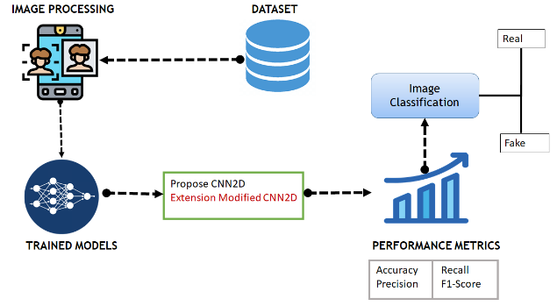
Fig.1 Proposed Architecture
The system architecture (Fig.1) depicted in the image illustrate architecture begins with image processing, where real and fake images are collected. These images are then stored in a dataset and used for image classification. Two models are trained on this dataset: a proposed CNN2D [15] and a modified CNN2D [16]. The trained models are then used to classify images as real or fake. The performance of these models is evaluated using metrics such as accuracy, precision, recall, and F1-score.
i) Dataset Collection:
The dataset used in this study contains two class labels: "FAKE" and "REAL." It consists of high-quality images generated by a synthetic data model (SDM), with synthetic images exhibiting complex attributes such as depth of field, reflections, and motion blur, making them difficult to distinguish from real photographs. Some images show visual imperfections, such as glitches and anatomical errors, while others feature realistic visual concepts like ripples in water and reflections.
ii) Pre-Processing:
The preprocessing steps involved in this study include image processing techniques such as resizing and converting images to grayscale, followed by data visualization to inspect image quality. Shuffling ensures randomness in training data, while normalization standardizes pixel values for improved model performance.
Image processing:
The dataset undergoes essential preprocessing steps, starting with loading and resizing images to a uniform size for consistency. Visualization techniques, such as class label distribution graphs, help assess data balance. Images are then normalized to scale pixel values between 0 and 1, ensuring uniformity. Shuffling is applied to randomize the data and eliminate bias, followed by splitting the dataset into training and testing subsets for model development and evaluation.
iii) Algorithms:
CNN2D: CNN2D is a convolutional neural network designed for image classification, leveraging convolutional and pooling layers to extract features. It effectively differentiates real and AI-generated images by learning visual patterns, ensuring reliable and accurate identification [15].
Modified CNN2D: Modified CNN2D enhances CNN2D with Global Average Pooling and Dropout layers, improving feature extraction and minimizing overfitting. [16] This optimized architecture delivers robust performance, accurately classifying subtle differences between real and AI-generated images for enhanced reliability.
4. RESULTS & DISCUSSION
Accuracy: The accuracy of a test is its ability to differentiate the patient and healthy cases correctly. To estimate the accuracy of a test, we should calculate the proportion of true positive and true negative in all evaluated cases. Mathematically, this can be stated as:
$$Accuracy=\frac{TP+TN}{TP+FP+TN+FN}(1)$$
Precision: Precision evaluates the fraction of correctly classified instances or samples among the ones classified as positives. Thus, the formula to calculate the precision is given by:
$$Precision=\frac{True Positive}{True Positive +False Positive}(2)$$
Recall: Recall is a metric in machine learning that measures the ability of a model to identify all relevant instances of a particular class. It is the ratio of correctly predicted positive observations to the total actual positives, providing insights into a model's completeness in capturing instances of a given class.
$$Recall=\frac{TP}{TP + FN}(3)$$
F1-Score: F1 score is a machine learning evaluation metric that measures a model's accuracy. It combines the precision and recall scores of a model. The accuracy metric computes how many times a model made a correct prediction across the entire dataset.
$$F1 Score=2*\frac{Recall X Precision}{Recall+Precision}*100( SEQ "equation" \backslash n \backslash * MERGEFORMAT 4)$$
Table (1) evaluate the performance metrics—Accuracy, precision, recall and F1-score —for each algorithm. The Modified CNN2D consistently outperforms compared to all other algorithms. The tables also offer a comparative analysis of the metrics for the other algorithm
Table.1 Performance Evaluation Table
Algorithm Name | Accuracy | Precision | Recall | F1-Score
CNN2D | 94.890 | 94.921031 | 94.895695 | 94.889489
Modified CNN2D | 95.775 | 95.829520 | 95.768225 | 95.773232
Graph.1 Comparison Graphs

Accuracy in blue, precision is represented in orange, recall in green and F1-Score in Sky blue in Graph (1). In comparison to the other models, the Modified CNN2D Model shows superior performance, achieving the highest values. The graphs above visually illustrate these findings.

Fig.2 Home Page
In above fig.2 user interface dashboard with navigation and a welcome message.

Fig.3 Registration Page
In above fig.3 sign-up form with fields for username, name, email, mobile number, and password buttons.

Fig.4 Login Page
In above fig.4 Sign-in form with username and password fields, and create a new account link.

Fig.5 Main Page
In above Fig.5 home page dashboard with navigation (Prediction, Graph, Notebook, Signout).

Fig.6 Upload Input Page
In above Fig.6 form with coordinate input field and upload button.
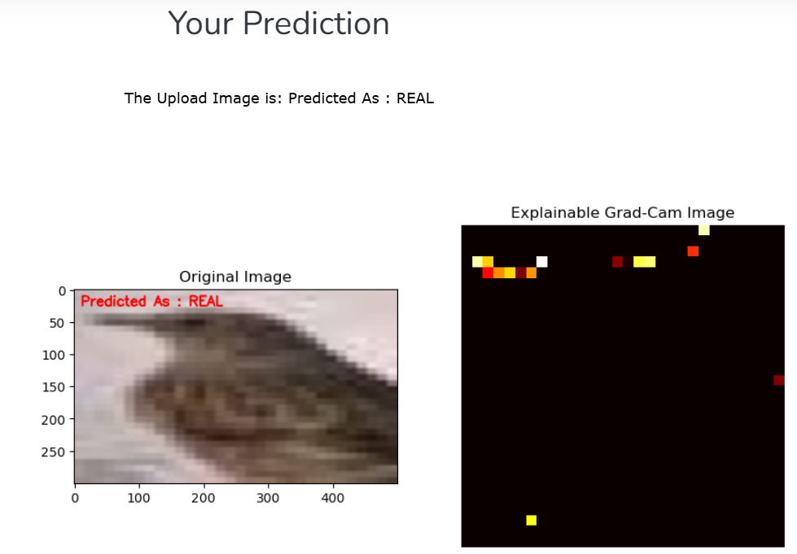
Fig.7 Predict Result for given input
In above Fig.7 Predicted result based on the input test data.
5. CONCLUSION
In conclusion, the project effectively addresses the growing challenge of differentiating between real and AI-generated images, a task that has become more difficult with the rapid advancements in synthetic data generation. By employing a robust modified CNN2D algorithm, the system demonstrates a high level of accuracy in image classification. The approach uses a synthetic dataset modeled after the CIFAR-10 dataset, generated through latent diffusion, to simulate real and AI-generated images for comparison. The modified CNN2D algorithm proves to be highly effective in distinguishing between these images, achieving an impressive accuracy of 95.77%. This high-performance model showcases the power of computer vision techniques in ensuring data authenticity and addressing the increasing concern of synthetic media. The results highlight the potential of modified CNN2D to enhance the reliability of image verification systems, offering a reliable solution for identifying AI-generated content and supporting the integrity of digital media.
The future scope of this work lies in enhancing the model's capability to detect AI-generated images in more complex and diverse datasets, including high-resolution images and various synthetic image generation techniques. Additionally, integrating advanced algorithms, such as generative adversarial networks (GANs) and transfer learning, could further improve performance. Expanding the system’s applicability to real-world scenarios, such as social media platforms, would help in combating the spread of synthetic media.
REFERENCES
[1] K. Roose, ‘‘An AI generated picture won an art prize. Artists aren’t happy,’’ New York Times, vol. 2, p. 2022, Sep. 2022.
[2] R. Rombach, A. Blattmann, D. Lorenz, P. Esser, and B. Ommer, ‘‘High-resolution image synthesis with latent diffusion models,’’ in Proc. IEEE/CVF Conf. Comput. Vis. Pattern Recognit. (CVPR), Jun. 2022, pp. 10684–10695.
[3] G. Pennycook and D. G. Rand, ‘‘The psychology of fake news,’’ Trends Cogn. Sci., vol. 25, no. 5, pp. 388–402, May 2021.
[4] B. Singh and D. K. Sharma, ‘‘Predicting image credibility in fake news over social media using multi-modal approach,’’ Neural Comput. Appl., vol. 34, no. 24, pp. 21503–21517, Dec. 2022.
[5] N. Bonettini, P. Bestagini, S. Milani, and S. Tubaro, ‘‘On the use of Benford’s law to detect GAN-generated images,’’ in Proc. 25th Int. Conf. Pattern Recognit. (ICPR), Jan. 2021, pp. 5495–5502.
[6] D.Deb,J. Zhang, and A. K. Jain, ‘‘AdvFaces: Adversarial face synthesis,’’ in Proc. IEEE Int. Joint Conf. Biometrics (IJCB), Sep. 2020, pp. 1–10.
[7] M. Khosravy, K. Nakamura, Y. Hirose, N. Nitta, and N. Babaguchi, ‘‘Model inversion attack: Analysis under gray-box scenario on deep learning based face recognition system,’’ KSII Trans. Internet Inf. Syst., vol. 15, no. 3, pp. 1100–1118, Mar. 2021.
[8] Z. Sha, Z. Li, N. Yu, and Y. Zhang, ‘‘DE-FAKE: Detection and attribution of fake images generated by text-to-image generation models,’’ 2022, arXiv:2210.06998.
[9] R. Corvi, D. Cozzolino, G. Zingarini, G. Poggi, K. Nagano, and L. Verdoliva, ‘‘On the detection of synthetic images generated by diffusio models,’’ 2022, arXiv:2211.00680.
[10] H. Li, B. Li, S. Tan, and J. Huang, ‘‘Identification of deep network generated images using disparities in color components,’’ Signal Process., vol. 174, Sep. 2020, Art. no. 107616.
[11] A. Krizhevsky and G. Hinton, ‘‘Learning multiple layers of features from tiny images,’’ 2009.
[12] D. Gunning, M. Stefik, J. Choi, T. Miller, S. Stumpf, and G.-Z. Yang,‘‘XAI—Explainable artificial intelligence,’’ Sci. Robot., vol. 4, no. 37, Dec. 2019, Art. no. eaay7120.
[13] A. Ramesh, M. Pavlov, G. Goh, S. Gray, C. Voss, A. Radford, M. Chen,and I. Sutskever, ‘‘Zero-shot text-to-image generation,’’ in Proc. Int. Conf.Mach. Learn., 2021, pp. 8821–8831.
[14] C. Saharia, W. Chan, S. Saxena, L. Li, J. Whang, E. Denton, S. K. S. Ghasemipour, B. K. Ayan, S. S. Mahdavi, R. G. Lopes, T. Salimans, J. Ho, D. J. Fleet, and M. Norouzi, ‘‘Photorealistic tex to-image diffusion models with deep language understanding,’’ 2022, arXiv:2205.11487.
[15] I. Amerini, L. Galteri, R. Caldelli, and A. Del Bimbo, ‘‘Deepfake video detection through optical flow based CNN,’’ in Proc. IEEE/CVF Int. Conf. Comput. Vis. Workshop (ICCVW), Oct. 2019, pp. 1205–1207.
[16] P. Saikia, D. Dholaria, P. Yadav, V. Patel, and M. Roy, ‘‘A hybrid CNN LSTM model for video Deepfake detection by leveraging optical flow features,’’ in Proc. Int. Joint Conf. Neural Netw. (IJCNN), Jul. 2022, pp. 1–7.

.

